# Overview

The components shown below are deployed in this demo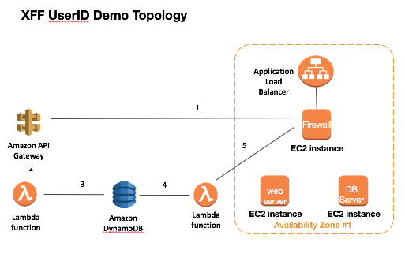

# Introduction

The demo performs the following actions.

1. In this demo we use the DVWA <http://www.dvwa.co.uk> to generate detectable threats between a browser and the web server. In this case we use a SQL Injection attack for demonstration purposes
2. The firewall will detect the SQL Injection threat and forward the log data to the AWS API Gateway via an HTTP log forwarding action.
3. The AWS API Gateway invokes a lambda function that queries the firewall for additional information based on the sessionID of the detected threat. The additional information includes the IP address in the X-Forwarded-For HTTP header. The additional data is written to a DynamoDB database.
4. A second Lambda function that is triggered from a Cloudwatch timer triggered event reads the current entries in the DynamoDB database and forwards them to the UserID database in the firewall.
5. The IP address from the X-Forwarded-For header is added to the “bad user” group and is then subject to a blocking policy in the firewall.

# Initial Setup

1. Load The Application Load Balancer Certificate

The application load balancer will require a certificate. Access the AWS Certificate Manager and select “Load Certificate”.

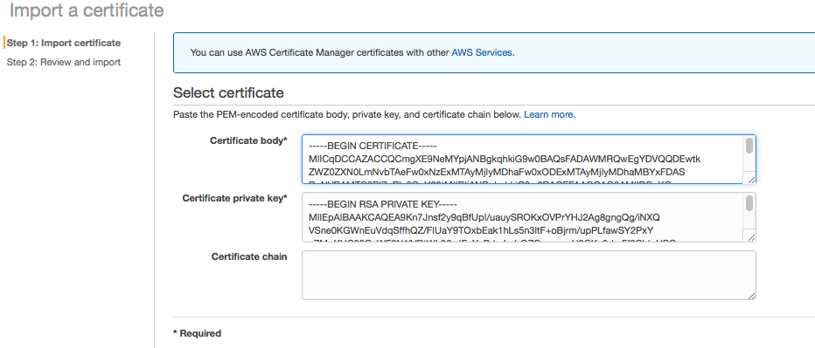

Paste in the text for the public and private key.

Make a note of the arn of the certicate as it is required by the Cloud Formation Template



1. Create the Bootstrap Buckets

More documentation required here but we can import from the existing Wordpress Demo.

1. Deploy the Cloud Formation Template



Check that the template deployment completes and make a note of the Wordpress URL which is the DNS name of the Application Load Balancer and the firewall management IP



1. Creat the API Gateway

Go to the AWS console and select API gateway

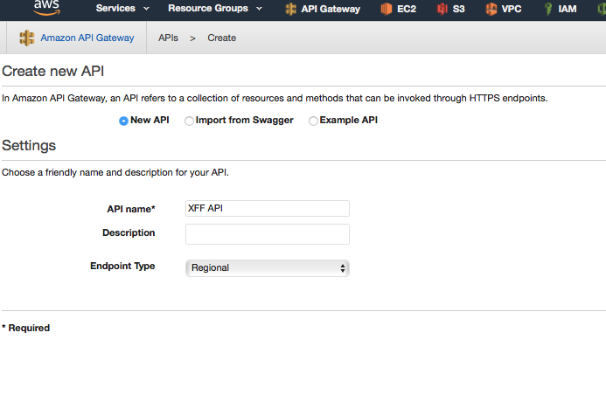

Select Actions and create a POST method

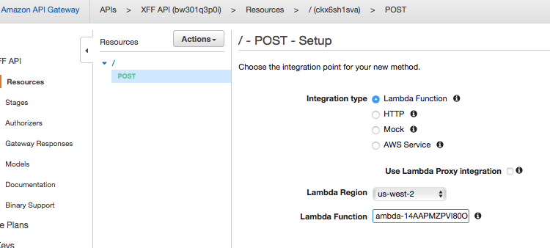

Add the lambda region and then the function.

The Lambda function will have the name {Stack Name}-GetXFFHeaderLambda-*

Next Deploy the gateway to a stage

After deployment copy the URL from the summary screen

Select Actions and then Deploy

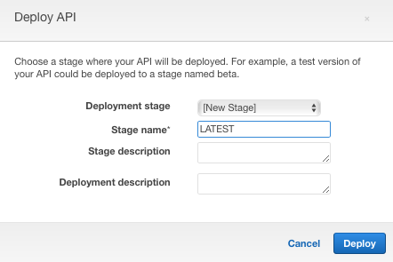



Extract the DNS name from the URL and modify the HTTP log forwarding values



Modify the “URI Format” under “Payload Format”



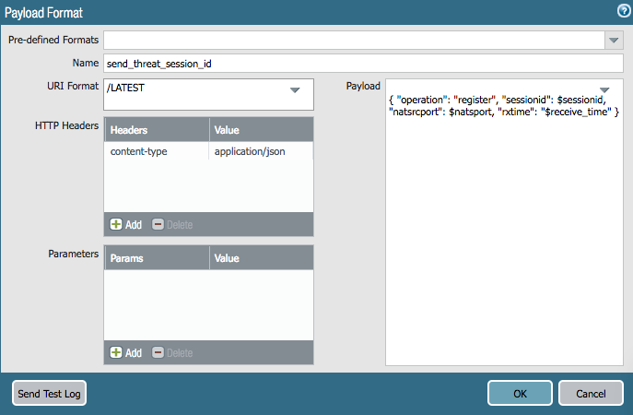

Once configured send a test log message



# Test the deployment

Open a browser and browse to the URL from the output of the cloud formation template

Setup the DVWA database





Login to the application using admin / password credentials

Lower the security level of the application to “Low”

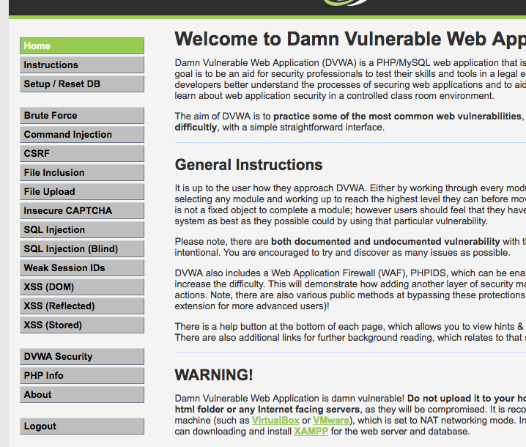

Next generate Threats using the SQL Injection tab

Details of SQL injection attacks that can be performed can be found here

<https://www.computersecuritystudent.com/SECURITY_TOOLS/DVWA/DVWAv107/lesson6/index.html>

For simplicity use %' or '0'='0

The firewall should block the attack and the browser will return a 502 bad Gateway error.

Check the firewall for threat logs

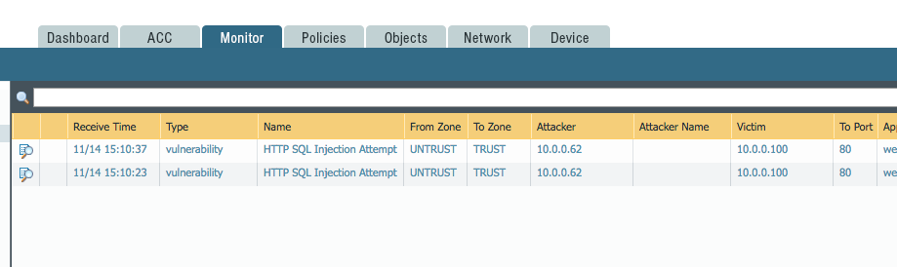

Check the cloudwatch logs.

If the threat log has been forwarded and processed logs will appear in cloudwatch under the log group corresponding to the lambda function

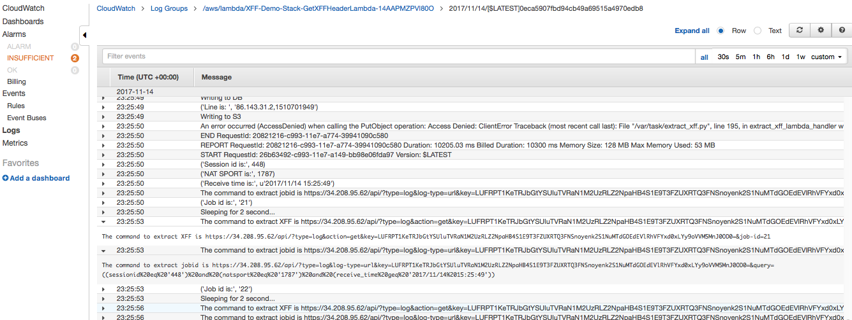

Checking DynamoDB should show the IP address in the database

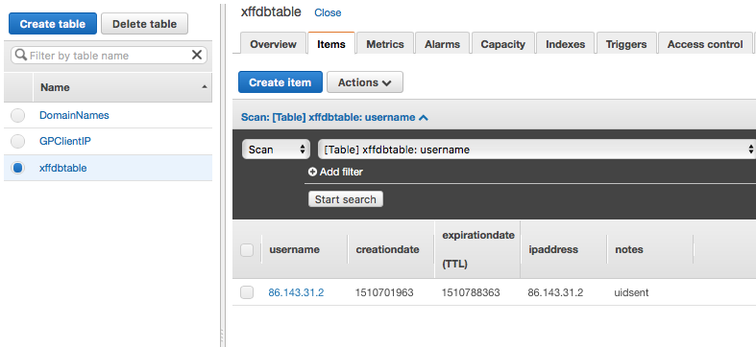

If the notes column indicates uidsent then the username IP has been sent to the firewall

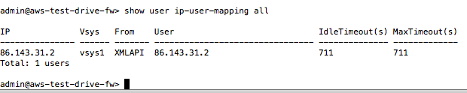

You should now receive a block page from the original URL

